LEGO MINDSTORM

Following a line edge

# Robot Setup

You can use almost any robot with turning capabilities.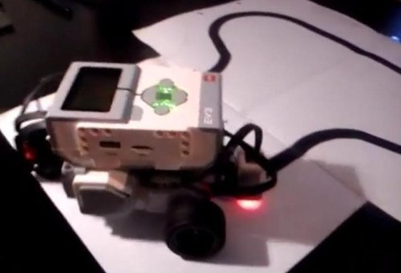

Set your colour sensor on the front of your robot.

LEGO MINDSTORM

Following a line edge

# Beginner Level – Zigzag following

Tip: Covering around the sensor so no light comes in will help get more accurate readings.

## Blocks needed

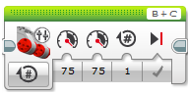 Move Tank

Check Motor Letters

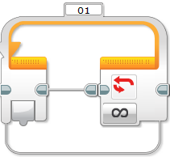 Loop

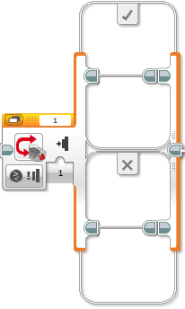 Switch

## Program

### Step 1 - Switch

Change your switch to compare Reflected Light Intensity

### Step 2 – Light Value

Once the light reflected is greater than 40 (between 20 – 40 test your own value) you’ll want to turn left or right to find the black line again.

Find your own values

Check Sensor Number

### Step 3 – Turning Motor

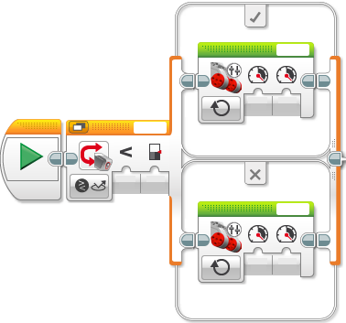

Find your own values

Put a Move Tank in each part of the switch.

Check Motor Letters

Test your values to turn left or right.

Tip: One will be less than the other and don’t make it too fast or your robot won’t find the line.

### Step 4 – Loop

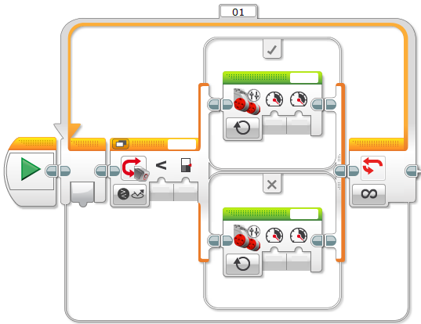You’ll want your robot to keep going, so you’ll need a loop.

This will go forever, however you’ll want it to stop.

Here are some suggestions for how to stop:

* Time – after 5 sec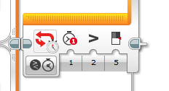
* Distance – after 5 rotations

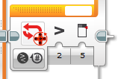

Check Motor Letter

LEGO MINDSTORM

Following a line edge

# Intermediate Level – Variable Steering

## Blocks Needed

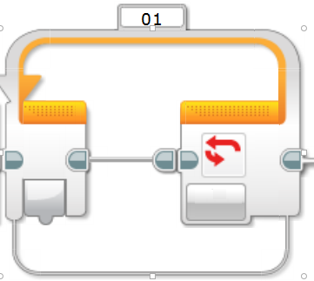Loop

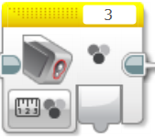Colour Sensor

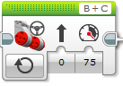Move Steering (On)

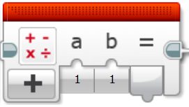Math Block

This block can be used in several different ways. Either use multiple blocks to perform your math calculations or use the “Advanced” option and write out your expression. Example 9*a-b/4+c. The less blocks you use the easier your program is to read. Make sure you add a label to explain your advanced math block.

## Program

### Step 1 – Loop

The loop is designed to continue the forward movement of the robot.

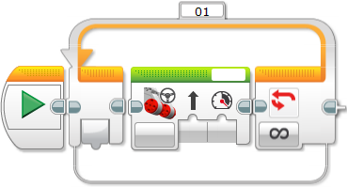

### Step 2 – Calculating Steering

The light sensor value is wired into the math block to perform calculations. The result of this calculation should be the desired value for steering.

Note: The steering value will change from the most left (-100) to the most right (100)

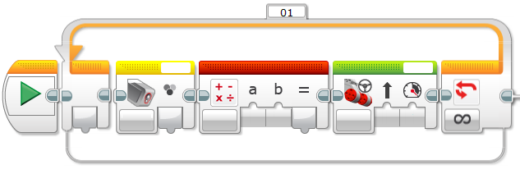

### Step 3 – Simplifying your Math Blocks

The math blocks can either be used in conjunction with each other or use an expression in the “Advanced” mode. For example:

$$25+2×4-\frac{8}{2}$$

This calculation can be performed by multiple math blocks.

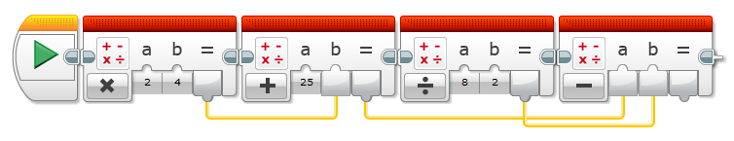

OR

The Advanced mode of the math block can be selected.

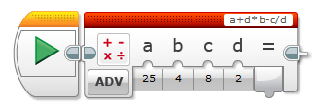

Both produce the EXACT same answer.

It’s up to you which style you will use for your calculations.

LEGO MINDSTORM

Following a line edge

# Advanced Level – Variable Steering and Variable Speed

## Blocks Needed

Loop

 Switch

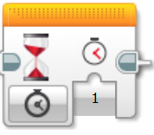Wait Block

Colour Sensor

Move Steering (On)

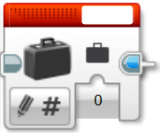Variable

Math Block

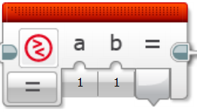Compare Block

# Answers

## Beginner Level - Answer

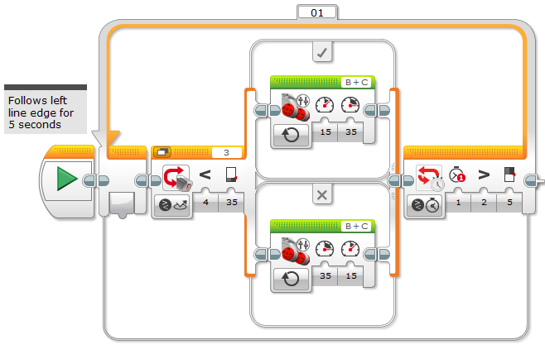

## Intermediate Level - Answer

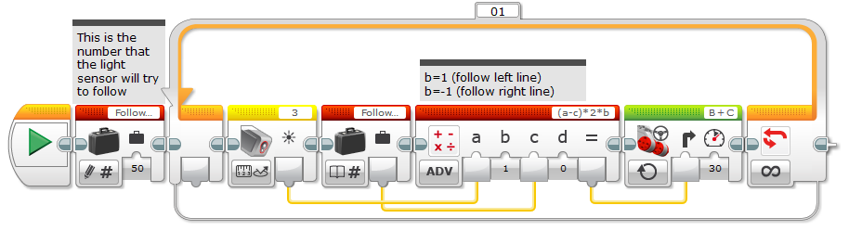

## Advanced Level - Answer

